Market Monitor - Burkina Faso - 2026-04

Highlights
Food prices in Burkina Faso continued their downward trend in April 2026, driven by falling costs for major staple cereals. This deflation provides some relief to consumers, with prices for all monitored commodities remaining significantly lower than the previous year.
The cost of the standard food basket decreased to 3,600.36, a drop of 1.3% (↓) from March and a substantial 28.5% (↓) decrease compared to April 2025. Millet saw the sharpest monthly price drop (↓3.6%), followed by maize (↓2.3%). In contrast, the price of beans (niebe) increased slightly (↑1.5%), running counter to the overall market trend.
Key drivers for this month's market dynamics include:
- Falling Cereal Prices: The overall market trend was driven by decreasing prices for key cereals. Millet and maize prices fell by 3.6% and 2.3% month-over-month, respectively, while sorghum remained stable.
- Significant Annual Deflation: Prices for all monitored commodities were substantially lower than last year. The food basket is 28.5% cheaper year-over-year, with major drops in the prices of maize (↓35.7%) and beans (↓31.0%).
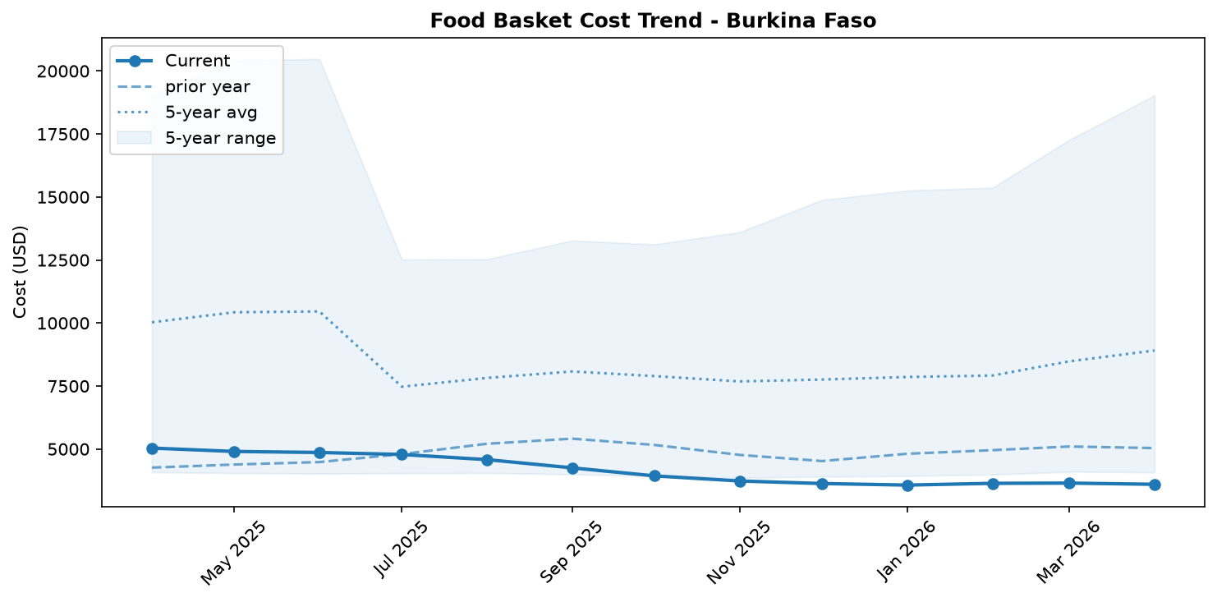
Food basket cost trend

Market Overview
Market conditions in April 2026 were characterized by a continued and significant deflationary trend, driven by weak household purchasing power and the impact of humanitarian assistance. The national average price of the food basket decreased by 1.3% month-over-month and fell by a substantial 28.5% compared to the same period last year. This downward pressure is primarily attributable to falling prices for key staple cereals, with maize and millet declining by 2.3% and 3.6% respectively during the month.
This price behavior presents a paradox amidst severe underlying food insecurity, with an estimated 1.7 million people affected and a national IDP population of 2 million. The deflation suggests that poor economic access, rather than food availability, is the primary constraint for many households. Reports of weak household incomes and the distribution of food assistance in crisis-affected areas are likely reducing market demand, preventing prices from reflecting the high level of need. While the return of over a million IDPs in 2025 has begun to reshape local market systems, their limited purchasing power continues to suppress overall demand, contributing to the persistent downward price trajectory.

Commodity Analysis
An analysis of individual commodities reveals a widespread, though uneven, deflationary trend in April, with most staples declining in price month-over-month. Millet experienced the sharpest monthly decrease at -3.6%, while maize, a key driver of the overall basket's deflation, saw its price fall by 2.3%. Sorghum prices remained stable compared to March but were still part of the significant annual downturn. Local rice registered a more modest monthly decrease of 0.6%.
Year-over-year, all monitored commodities have seen dramatic price reductions, signaling a major market correction from the high prices of the previous year. Maize has seen the most substantial annual drop at -35.7%, followed by beans (-31.0%), sorghum (-28.4%), and millet (-27.1%). Local rice, while still down significantly, had the least severe annual deflation at -15.4%.
Running counter to the general monthly trend, the price of beans (niebe) increased slightly by 1.5%. This minor increase does little to offset its massive 31.0% year-over-year price fall. The overarching narrative remains one of significant annual deflation across the entire food basket, driven by weak consumer demand for staple cereals.
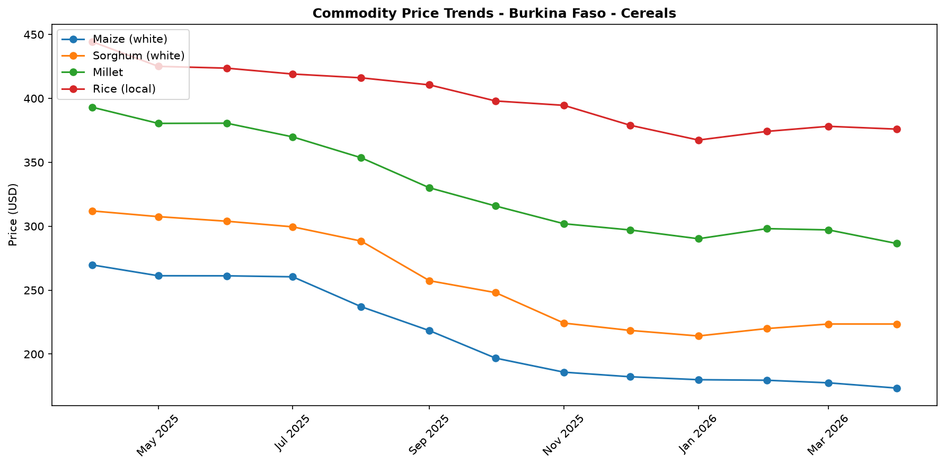
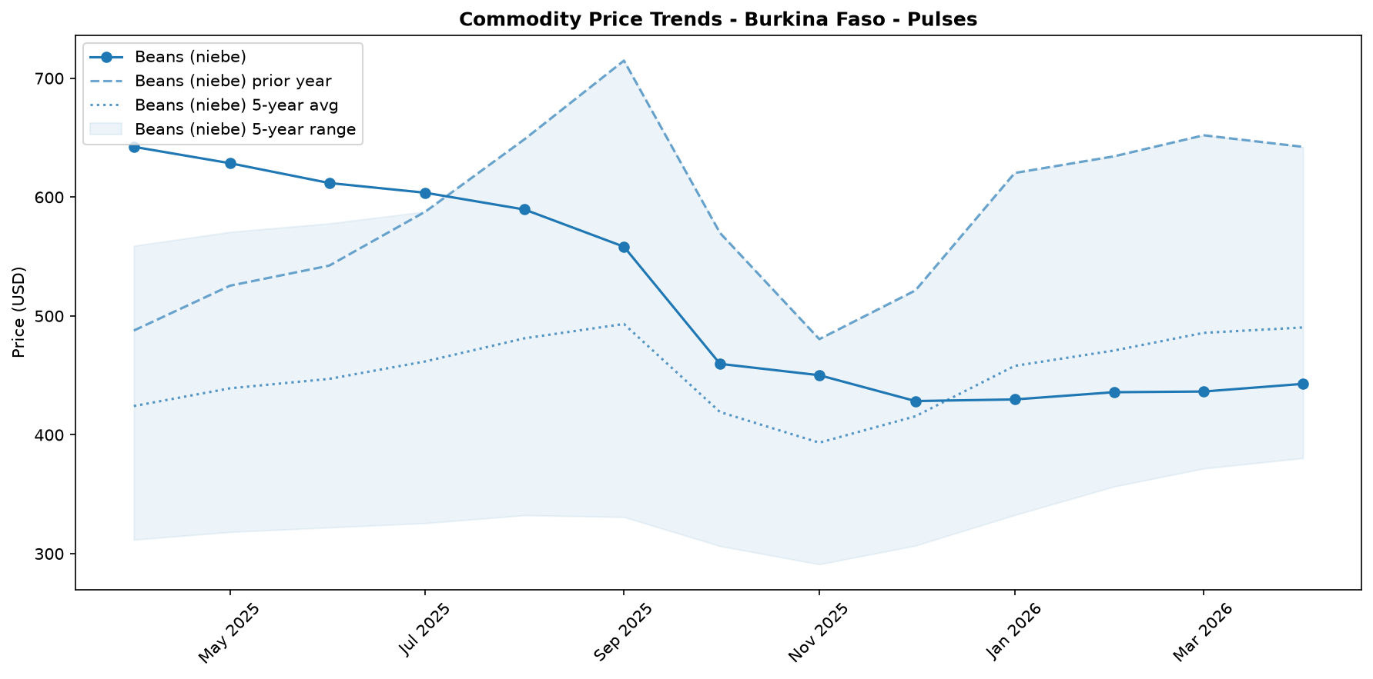

Regional Highlights
At the national level, markets across Burkina Faso are defined by significant price deflation, a trend that masks severe household-level food access challenges.
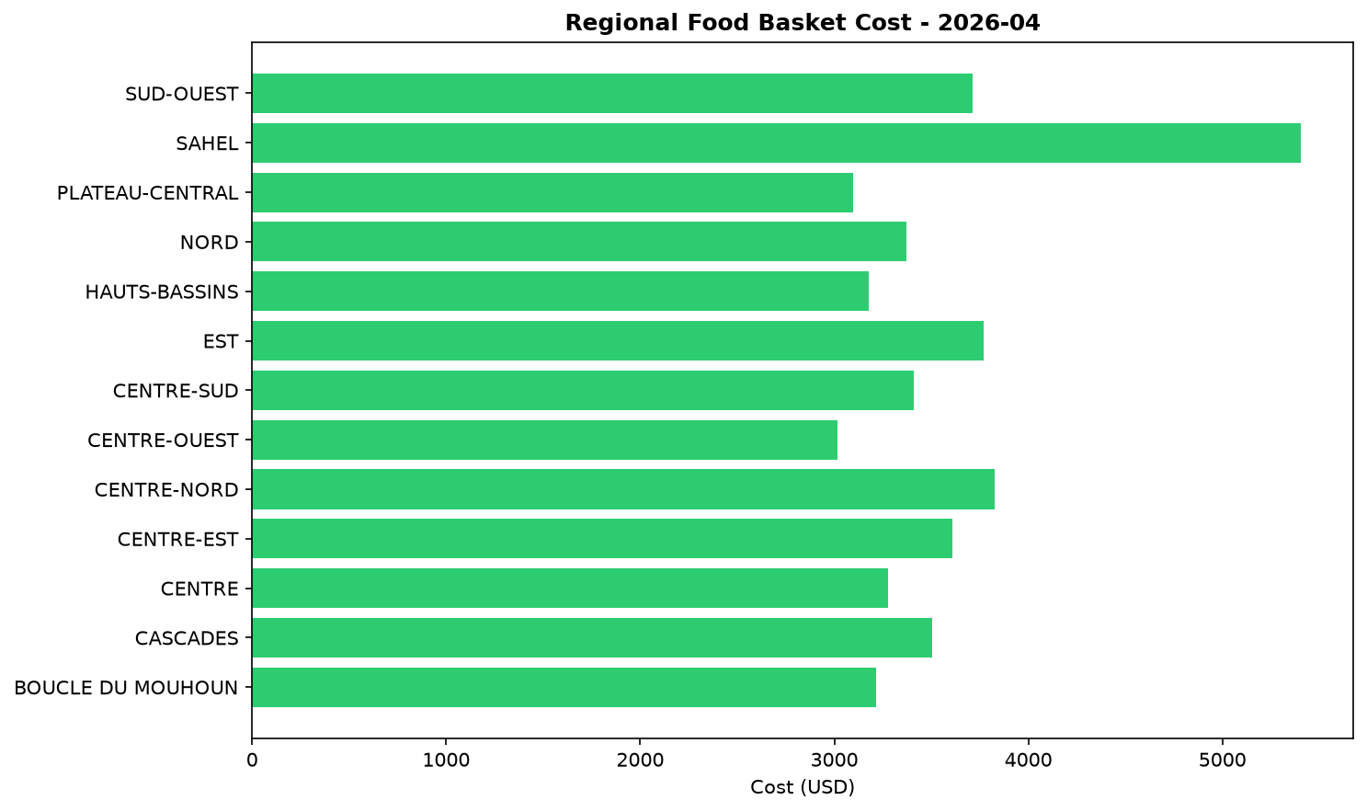
The national food basket price fell by 1.3% from March to April and is now 28.5% lower than one year ago. This trend is observed across most regions, though with some local variations. The dynamics in areas like Karo-Peli Province provide a clear illustration of the underlying drivers. Despite persistent Crisis (IPC Phase 3) food security outcomes, weak household incomes limit the ability of vulnerable populations to purchase cereals on the market. Furthermore, the provision of food assistance in March to half the province's population, covering at least 50% of their needs, has substantially reduced pressure on market demand. This combination of extremely low purchasing power and in-kind aid is a key factor putting downward pressure on prices, even in a context of high food insecurity.

References
- [rw_4208918] ReliefWeb (2026-04-22) UNICEF Executive Director Catherine Russell’s remarks at the Humanitarian Dialogue – Humanitarian Priorities for Children in 2026
https://reliefweb.int/node/4208918
- [rw_4208090] ReliefWeb (2026-04-17) Rapport final indice de fonctionnalite des marches 2025
https://reliefweb.int/node/4208090
- [rw_4207091] ReliefWeb (2026-04-13) WFP Burkina Faso Country Brief, March 2026
https://reliefweb.int/node/4207091
- [rw_4207009] ReliefWeb (2026-04-13) Burkina Faso Key Message Update: Crisis (IPC Phase 3) persists in the north and east amid the lean season, March - September 2026
https://reliefweb.int/node/4207009
- [rw_4206645] ReliefWeb (2026-04-09) Integrating nutrient supplements and WASH into agriculture programs improves child micronutrient status in Burkina Faso
https://reliefweb.int/node/4206645
- [rw_4205328] ReliefWeb (2026-03-31) West and Central Africa: Latest Events at a glance (24 - 30 March 2026)
https://reliefweb.int/node/4205328
- [rw_4205099] ReliefWeb (2026-03-30) Bi-monthly Pastoral Surveillance bulletin in the Sahel N°35 / October-November 2025
https://reliefweb.int/node/4205099
- [rw_4205066] ReliefWeb (2026-03-30) Bi-monthly Pastoral Surveillance bulletin in the Sahel N°36 / December 2025 - January 2026
https://reliefweb.int/node/4205066
- [rw_4204694] ReliefWeb (2026-03-27) Situation in Central Sahel, Liptako Gourma and Coastal Countries - DTM Monthly Dashboard #65 (February 2026)
https://reliefweb.int/node/4204694
- [rw_4204486] ReliefWeb (2026-03-26) UNICEF West and Central Africa Region Humanitarian Situation Report No. 2 (End of Year), 31 December 2025
https://reliefweb.int/node/4204486
- [seerist_1028284] Seerist (2026-04-24) Government purchase of stake in mine underlines HIGH regulatory, contract risks for mining operators
- [seerist_1028238] Seerist (2026-04-21) Big Picture series: Hard currency decisions – Sahel juntas unlikely to abandon CFA franc
- [seerist_1028144] Seerist (2026-04-14) Big Picture series: Strait of Hormuz disruption to drive acute fiscal, supply chain challenges in Africa
- [seerist_1027861] Seerist (2026-03-20) Big Picture series: Beyond health – the implications of the America First Global Health Strategy

